Marco Theo A. Butalid  
09/16/2018  
CSIT01

PS: make sure you already have an GITHUB account.

Step 1: Install Git.

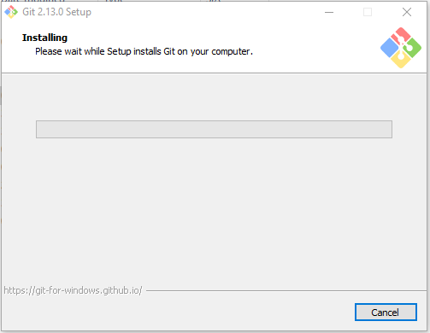

Step 2: Install TortoiseSVN that is compatible with your pc as for this example im gonna use 64bit.

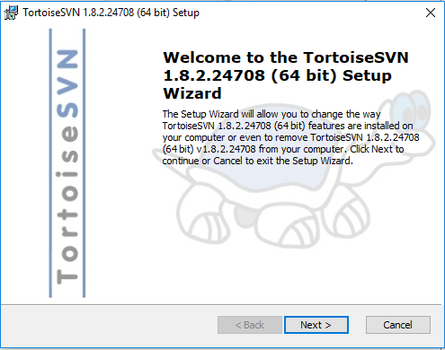

Step 3: Create folder and name it under your projects name.



Step 4: Right click the folder and click SVN checkout then copy your repository then click ok which will show the following window below.

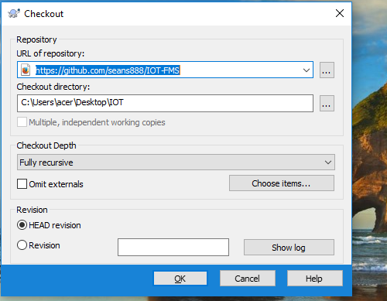

Step 5: Add file in the folder you created.

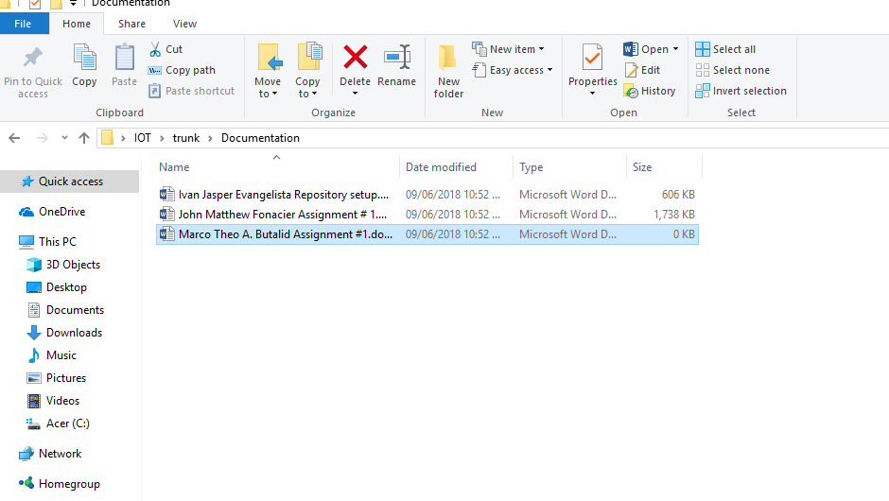

Step 6: Right click on the file you created and click on TortoiseSVN then click add.

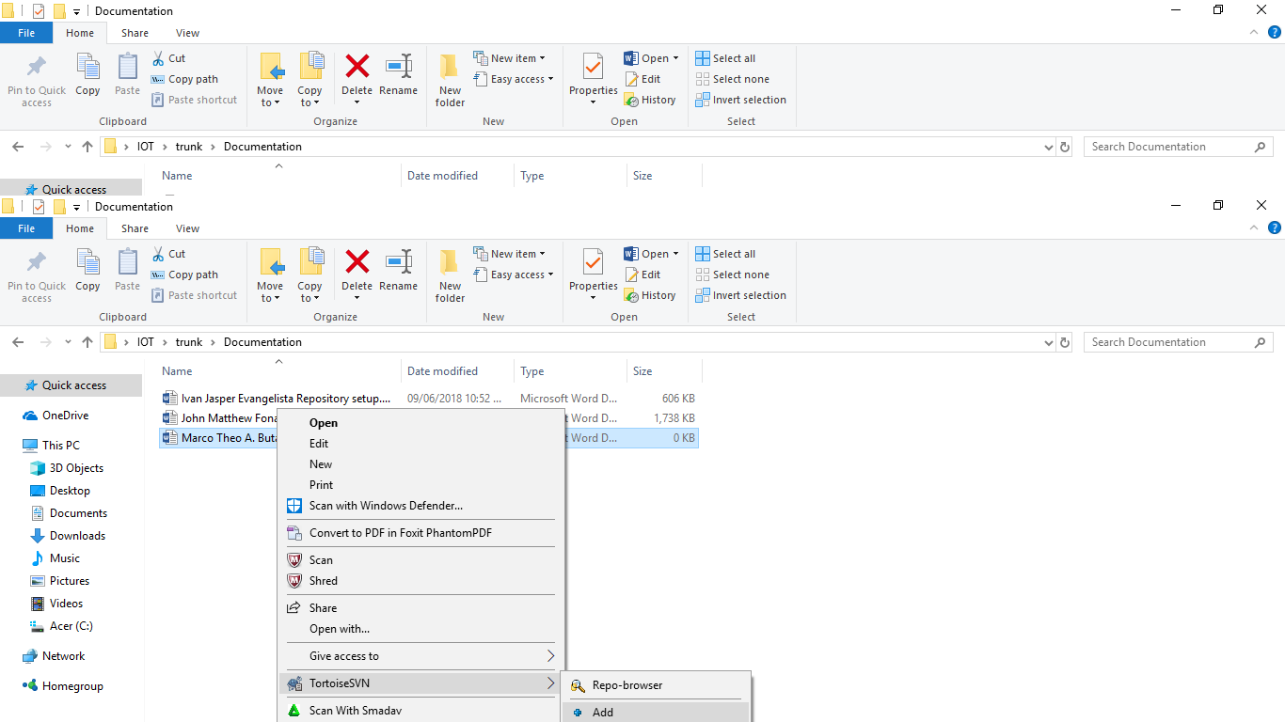

Step 7: Then right click the folder where you created your file in and click SVN commit.

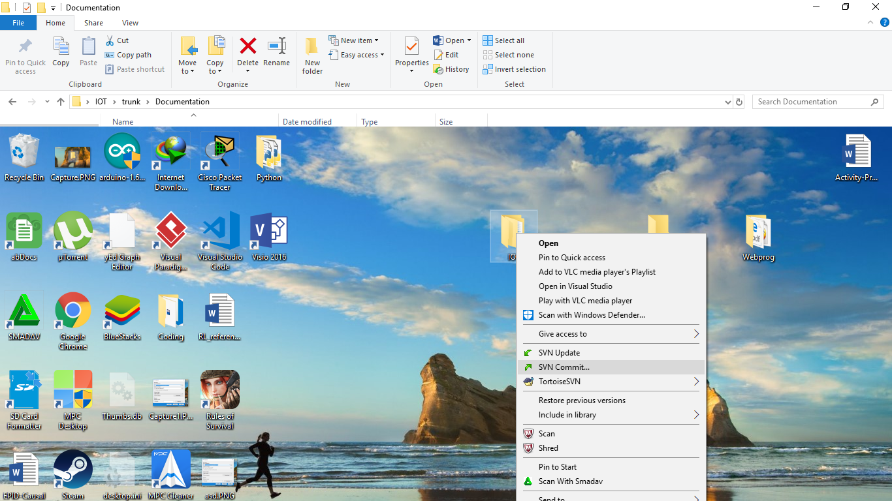

Step 8: Then click check the path you are committing and click ok.

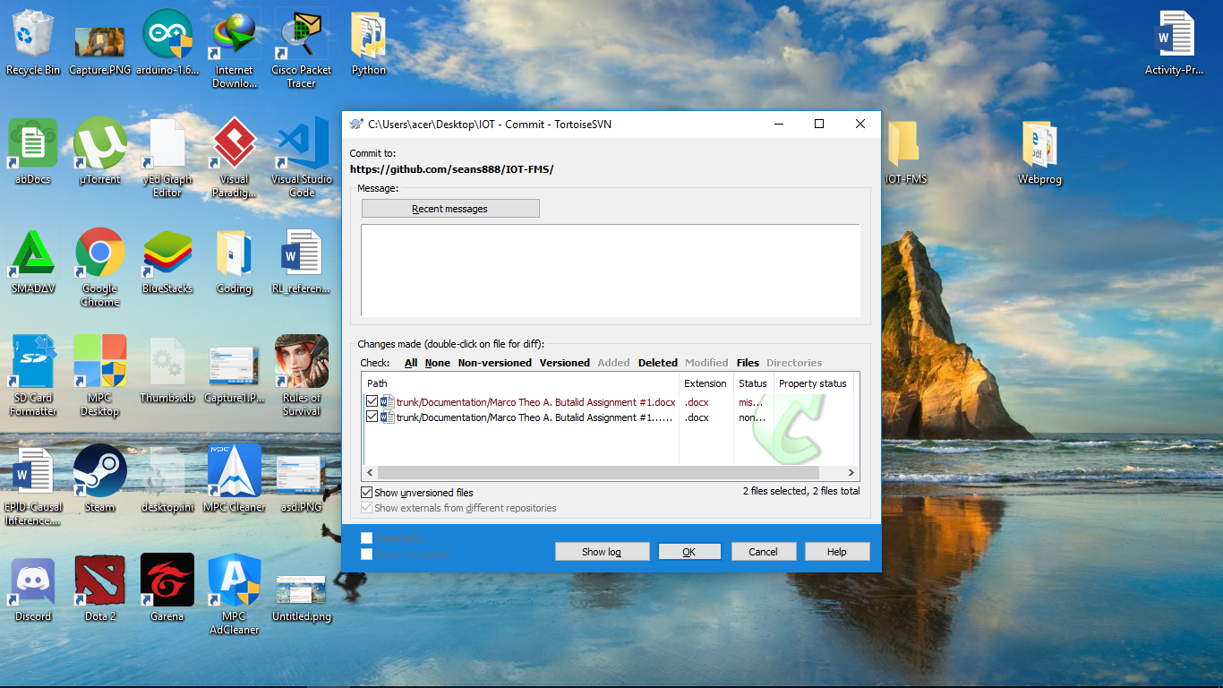

Step 9: Then you have to enter your credentials using your github account.

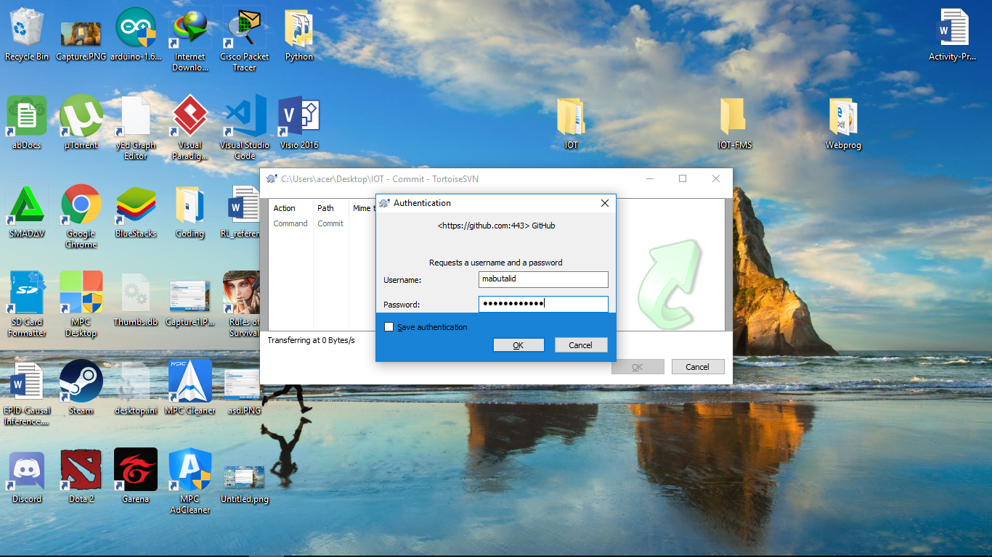

Step 10: after a while a window like this will appear which will show that you are finish to commit then press ok.

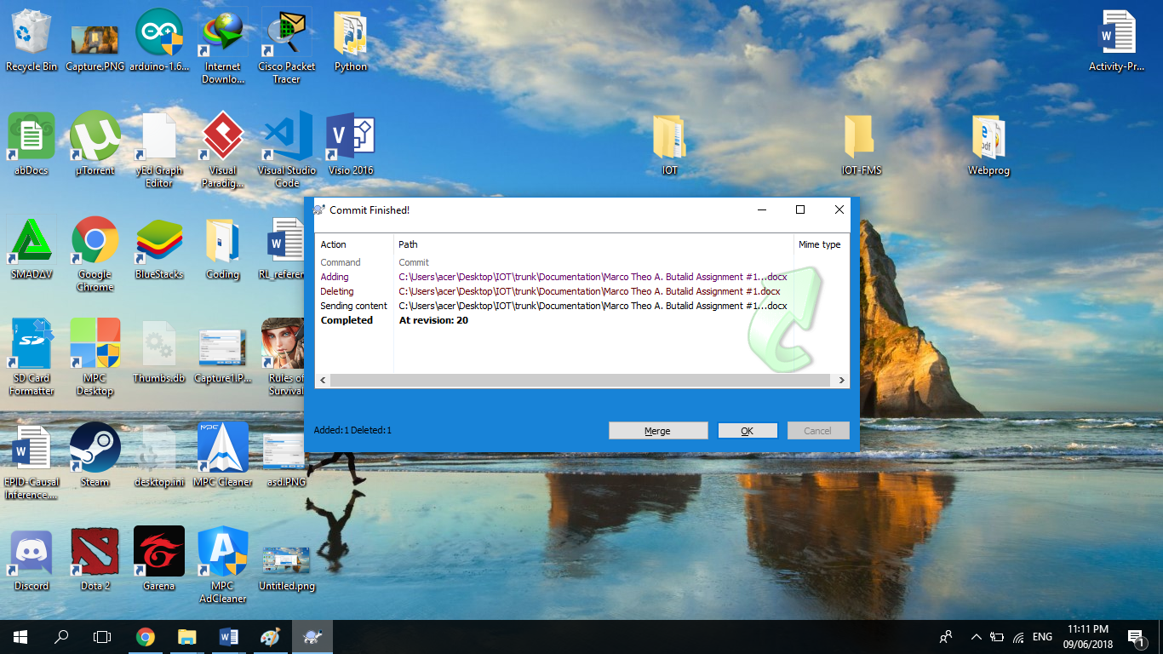

Step 11: then right click on your folder again then click SVN update to update your folder.



Step 12: Then once its finish click ok.

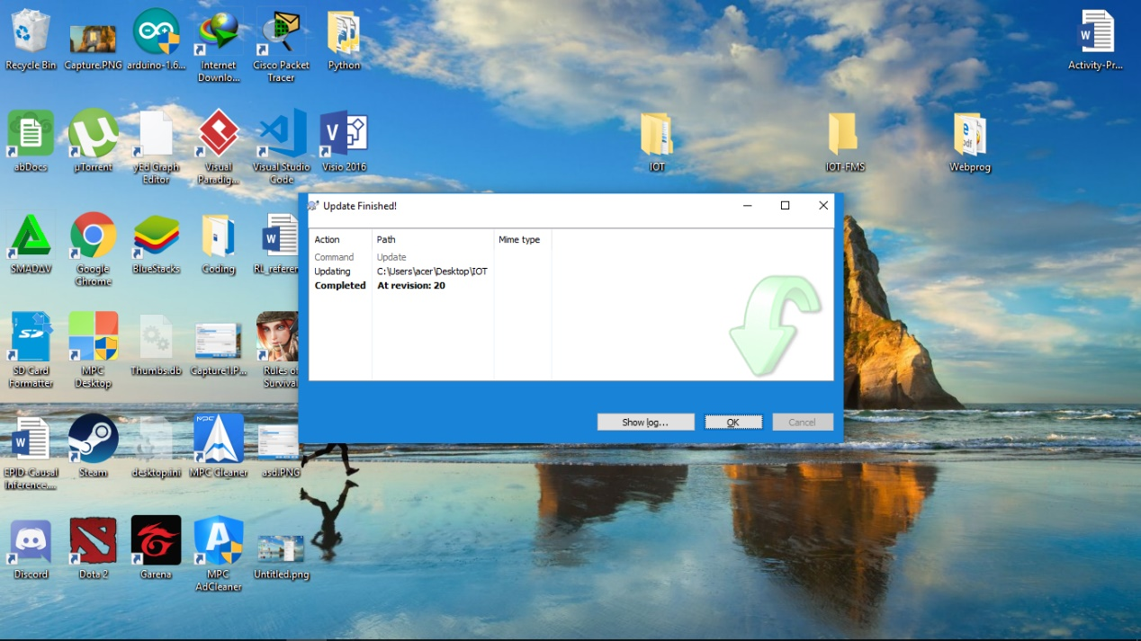

Then if you want to commit again just do those steps again starting by adding or deleting files in your project folder.

Done!